WEEK 13 ASSIGNMENTS RDBMS

1. **Use the following and perform the queries**

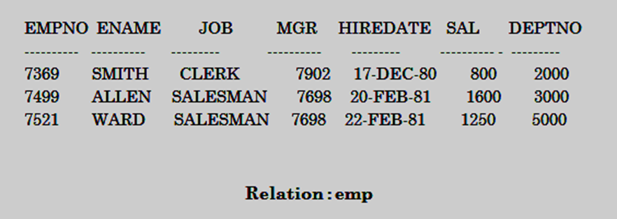

1. Select only employee number with name and salary.
2. Fetch employee number, name, job, mgr, hiredate s alary, deptno, from employee.
3. Select Employees those who not getting salary range from 500to5000.
4. Select employees whose salary is(800,5000).
5. Select employee name with starting letter ‘s’.